Title here:
Name Candidate’s academic degrees
Candidate’s ORCID

A thesis submitted for the degree of Doctor {Master} of Philosophy at
The University of Queensland in {year}
Name of the Enrolling Unit

Abstract
Start this section on a new page.

The abstract should outline the main approach and findings of the thesis and normally must be between 300 and 800 words.

Declaration by author
Start this section on a new page.
(All candidates to reproduce this section in their thesis verbatim)

This thesis is composed of my original work, and contains no material previously published or written by another person except where due reference has been made in the text. I have clearly stated the contribution by others to jointly-authored works that I have included in my thesis.

I have clearly stated the contribution of others to my thesis as a whole, including statistical assistance, survey design, data analysis, significant technical procedures, professional editorial advice, financial support and any other original research work used or reported in my thesis. The content of my thesis is the result of work I have carried out since the commencement of my higher degree by research candidature and does not include a substantial part of work that has been submitted to qualify for the award of any other degree or diploma in any university or other tertiary institution. I have clearly stated which parts of my thesis, if any, have been submitted to qualify for another award.

I acknowledge that an electronic copy of my thesis must be lodged with the University Library and, subject to the policy and procedures of The University of Queensland, the thesis be made available for research and study in accordance with the Copyright Act 1968 unless a period of embargo has been approved by the Dean of the Graduate School.

I acknowledge that copyright of all material contained in my thesis resides with the copyright holder(s) of that material. Where appropriate I have obtained copyright permission from the copyright holder to reproduce material in this thesis and have sought permission from co-authors for any jointly authored works included in the thesis.

Publications included in this thesis
Start this section on a new page.
If you choose to include publications as part of your thesis as described in UQ policy (PPL 4.60.08 Higher Degree by Research Examination) use this section to detail accepted or in press publication/s using the standard citation format for your discipline.

Papers submitted for publication and awaiting review should appear in the next section, Submitted manuscripts included in this thesis.

On the page immediately preceding the chapter that includes your publication, in no more than one
(1) page, describe your contribution to the authorship if you are not a sole author. In describing your contribution, you must satisfy the University’s authorship policy (PPL 4.20.04 Authorship). Authorship is based on having made a substantive contribution to at least one, and usually more than one, of the following activities:

- conception and design of the project;

- analysis and interpretation of the research data on which the publication is based;

- drafting significant parts of the publication or critically reviewing it so as to contribute to the interpretation.

As an author, you must have participated sufficiently in the publication to take public responsibility for at least that part of the work that you contributed.

It may be useful to refer to specific parts of the methods, analyses, results, or discussion to illustrate your contribution to the paper.

If you have not included any of your publications in the thesis then state “No publications included”.

Example:

- [1] Your Name, Co-author 1, and Final Author, Title of your paper, Journal, Issue, Number, Year

- [1] Your Name, Co-author 1, and Final Author, Title of your paper, Journal, Issue, Number, Year

Submitted manuscripts included in this thesis
List manuscript/s submitted for publication here. As described above for Publications included in the thesis, on the page immediately preceding the chapter that includes the submitted manuscript, in no more than one (1) page, detail your contribution to the authorship if you are not the sole author.

If you have no submitted manuscripts from your candidature then state “No manuscripts submitted for publication”.

Example:

- [1] Your Name, Co-author 1, and Final Author, Title of your paper, submitted to Journal on 4th June 2018.

Other publications during candidature
List other publications arising during your candidature using the standard citation format for your dis- cipline. Divide your publications into sub-sections as appropriate in your discipline e.g. peer-reviewed papers, book chapters, conference abstracts. Papers submitted for publication and awaiting review are not considered publications and cannot be included in this section.

If you have no publications from your candidature then state “No other publications”.

Example:

Conference abstracts
- [1] Your Name, Co-author 1, and Final Author, Title of your conference paper, Proceedings of Conference, other details.

Book chapters
- [1] Your Name, Co-author 1, and Final Author, Title of your chapter, Book, editor, etc..

Contributions by others to the thesis
List the significant and substantial inputs made by others to the research, work and writing represented and/or reported in the thesis. These could include significant contributions to: the conception and design of the project; non-routine technical work; analysis and interpretation of research data; drafting significant parts of the work or critically revising it so as to contribute to the interpretation.

If no one contributed significantly then state “No contributions by others”.

Statement of parts of the thesis submitted to qualify for the award of another degree
The thesis must be comprised only of research undertaken while enrolled in the HDR program unless otherwise approved by the Dean, Graduate School in advance of submission.

If you have been given permission to include your previous work that has been used towards another degree, you must list the relevant parts of the thesis that incorporates this work including, the degree name, year and institution, and the outcome of the submission of material.

If no parts of the thesis have been submitted in this way then state “No works submitted towards another degree have been included in this thesis”.

Research involving human or animal subjects
All research involving human or animal subjects requires prior ethical review and approval by an independent review committee. At UQ, the relevant committee for research involving human subjects is the Human Ethics Unit and the relevant committee for research involving animal subjects is the relevant Animal Ethics Committee. Please provide details of any ethics approvals obtained including the ethics approval number and name of approving committees. A copy of the ethics approval letter must be included in the thesis appendix.

If no human or animal subjects were involved in this research please state: “No animal or human subjects were involved in this research”.

Acknowledgments
Start this section on a new page.

Acknowledgements recognise those who have been instrumental in the completion of the project. Acknowledgements should include any professional editorial advice received including the name of the editor and a brief description of the service rendered.

Financial support
Start this section on a new page.

If you are the recipient of an Australian Government Research Training Program (RTP) scholarship, you are required to acknowledge this contribution. Please include the text below:

“This research was supported by an Australian Government Research Training Program Scholarship”

If you received any other financial support for your project, you are also required to acknowledge the funding body/bodies in this section.

If no financial provided then state “No financial support was provided to fund this research”.

Order for the Remainder of the Thesis
Remainder of the thesis should be in the following order

- Dedications (if applicable)

- Table of Contents

- List of Figures and Tables

- List of Abbreviations used in the thesis

- Main text of the thesis

- Bibliography or List of References

- Appendices

The following pages include examples of how the rest of the thesis should be formatted. However, there may be discipline-specific requirements regarding the remainder of your thesis. Therefore we recommend that you discuss this with your advisory team.

Dedication (if applicable)

Contents

Abstract . . . . . . . . . . . . . . . . . . . . . . . . . . . . . . . . . . . . . . . . . . . . | ii
Contents | xi
List of Figures | xii
List of Tables | xiii
List of Abbreviations and Symbols | xv
1 Introduction | 1
1.1 Your thesis topic . . . . . . . . . . . . . . . . . . . . . . . . . . . . . . . . . . . . . | 1
2 Abbreviated title | 3
2.1 Introduction . . . . . . . . . . . . . . . . . . . . . . . . . . . . . . . . . . . . . . . | 3
3 Conclusion | 5
Bibliography | 7
A Appendix | 9
A.1 Name of Appendix-1 . . . . . . . . . . . . . . . . . . . . . . . . . . . . . . . . . . | 9
A.2 Name of Appendix-2 . . . . . . . . . . . . . . . . . . . . . . . . . . . . . . . . . . | 9
B Example of Citations | 11
C Example of Code | 13
C.1 Find the greatest number from a list of numbers in Python . . . . . . . . . . . . . . . | 13
D Example of Equations | 15
E Example of Figures | 17
F Example of Flow Charts | 19
G Example of Tables | 21

List of Figures

E.1 The University Of Queensland 17
F.1 Flow Chart 19

List of Tables

G.1 Name of the Australian Cities 21

List of Abbreviations and Symbols

Abbreviations

AC Alternating Current
AFM Atomic Force Microscopy/Microscope
etc. etc.

Symbols
ρˆ

Density operator

etc. etc.

Chapter 1

Introduction

1.1 Your thesis topic
Introduce your topic.

The following publication has been incorporated as Chapter 2.
1. [1] Your Name, Co-author 1, and Final Author, Title of your paper, Journal Issue, Number, Year

Contributor | Statement of contribution | %
Your Name | writing of text  proof-reading | 70  60
 | theoretical derivations | 70
 | numerical calculations | 100
 | preparation of figures | 80
 | initial concept | 10
Co-author 1 | writing of text | 20
 | proof-reading | 10
 | supervision, guidance | 20
 | theoretical derivations | 10
 | preparation of figures | 20
 | initial concept | 10
Final Author | writing of text | 10
 | proof-reading | 30
 | supervision, guidance | 80
 | theoretical derivations | 20
 | preparation of figures | 10
 | initial concept | 80

If your task breakdown requires further clarification, do so here. Do not exceed a single page.

Chapter 2

Full title

Introduce the broad layout of the chapter.

2.1 Introduction
Add your text here.

Chapter 3

Conclusion

Conclude your thesis.

Bibliography

- Y. Name, C. author 1, F. Author, Title of your journal/conference paper, Name of the jour- nal/conference proceeding 00 (00) (20–) 00–00.
- M. Cawvey, M. Hayes, D. Canache, J. J. Mondak, Personality and Political Behavior, Vol. 1, Oxford University Press, 2017. doi:10.1093/acrefore/9780190228637.013.221.
URL http://politics.oxfordre.com/view/10.1093/acrefore/9780190228637.001. 0001/acrefore-9780190228637-e-221
- R. Pakzad, S. Wang, S. Sloan, Numerical Study of the Failure Response and Fracture Propagation for Rock Specimens with Preexisting Flaws under Compression, International Journal of Geome- chanics 18 (7) (2018) 04018070. doi:10.1061/(ASCE)GM.1943-5622.0001172.
URL http://ascelibrary.org/doi/10.1061/{%}28ASCE{%}29GM.1943-5622.0001172

- J. Adachi, E. Siebrits, A. Peirce, J. Desroches, Computer simulation of hydraulic fractures, International Journal of Rock Mechanics and Mining Sciences 44 (5) (2007) 739–757.
- J. Fenwick, L. Gross, Lazy evaluation of pde coefficients in the escript system, in: J. Chen,
R. Ranjan (Eds.), Eighth Australasian Symposium on Parallel and Distributed Computing (AusPDC 2010), Vol. 107 of CRPIT, ACS, Brisbane, Australia, 2010, pp. 71–76.
URL http://crpit.com/confpapers/CRPITV107Fenwick.pdf

- R. H. Peerlings, Enhanced damage modelling for fracture and fatigue, Ph.D. thesis, Eindhoven University of Technology (1999).
- M. Panis, Experimental identification of a damage evolution law for steel, Tech. rep., Faculty of Mechanical Engineering, Eindhoven University of Technology (2004).

Appendix A

Appendix

Write your appendix here. Following two are examples.

Name of Appendix-1

  - Name of Appendix-2

Appendix B

Example of Citations

This text is only for Bibliography testing purposes. This is a book by Cawvey et al. [2]. There are few journal articles [3, 4] in this bibliography. This is a proceeding paper [5]. This is a PhD thesis by Peerling [6]. These are few other types of citations [7].

Appendix C

Example of Code

Find the greatest number from a list of numbers in Python

a=[1,2,3,4,6,7,99,88,999]
max= 0
for i in a:
if i > max:
max=i print(max)

Appendix D

Example of Equations

E = mc² (D.1)

a = b + c (D.2)
x = y + z (D.3)

a = b + c
+ d + e

sinx + cosx = 1 (D.4)

Appendix E

Example of Figures

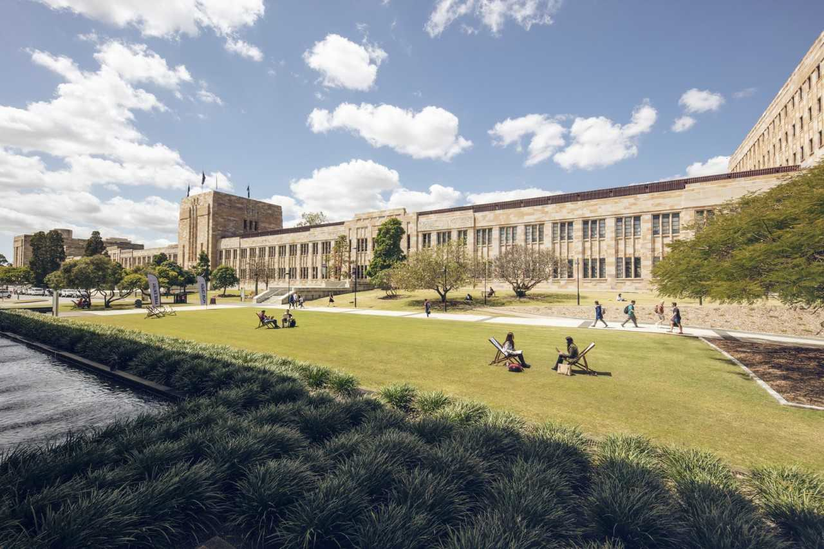

Figure E.1: The University Of Queensland

The Figure E.1 represents beauty of the UQ campus.

Appendix F

Example of Flow Charts

Figure F.1: Flow Chart

expert
initialize model
system
identify candidate models
update model
evaluate candidate models
yes
is best candidate better?
no

stop

Flow chart F.1 is a simple example.

Appendix G

Example of Tables

Here is a really simple table G.1.

Table G.1: Name of the Australian Cities

Number | Name
1 | Brisbane
2 | Sydney
3 | Melbourne
4 | Canberra
5 | Perth
6 | Adelaide
7 | Hobart
8 | Darwin

Endquote goes here.

Author of quote, Source of quote

