10 Point Tibetan Meditation
Sit comfortably cross legged on the floor (use a wall for support) OR use a chair, sitting at the edge of the seat with a straight spine.
Allow the physical movements to follow the flow of the breath. Focus on synchronous, deliberate, and focused movements between the breath and body movements.
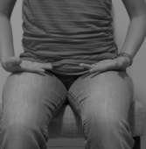
- When you’re ready, take a deep breath in, and slowing exhale. On your next inhalation draw a deep breath into the lower lungs, the chest and abdomen should expand on the in-breath. Bring the back of the hands to a resting position on hip/upper thigh crease

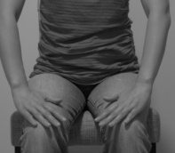

- EXHALE: rotate hands inward towards the abdomen and fan out, palms down over the knees

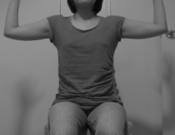
- INHALE: fingers spread, hands lift, elbows up parallel to shoulders, shoulders down
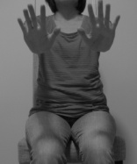

- BREATHE OUT: Push hands directly forward

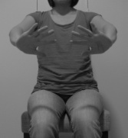
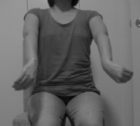
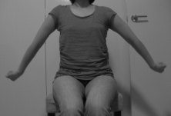
- BREATHE IN: rotate hands in, abduct arms out along side – nerve stretch – shoulder rolled forward and down, hands pinched and stretch to elbows

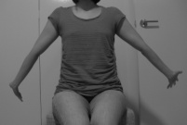
- BREATHE OUT: Rotate Arms open, elbows facing front, shoulder blades down, palms open and fingers stretch back to elbows for median nerve stretch
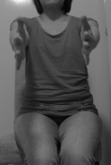

- BREATHE IN: Hands drawn forward parallel to each other

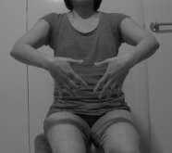
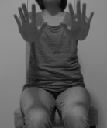
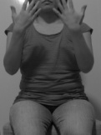
- BREATHE OUT: Rotate hands palms towards the face, then in a fluid sweeping motion, down the trunk of the body and push hands palms forward as if pushing the air away

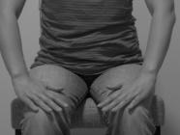
- BREATHE IN: Hands palm down slowly lower over the knees

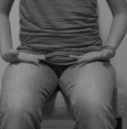
- BREATHE OUT: Hands rotate out away from the thighs, and draw the up-turned palms to rest on hip/upper thigh crease

- BREATHE IN, EXHALE, on the INHALATION begin again from step 2

